Turquoise Hotel is situated in Sorgun pine forest which reaches out to the sea. The hotel has easy access to ancient Side (3.5 km), Manavgat (4.5 km) and Antalya Airport (65 km). Taxis and other public transport are available.

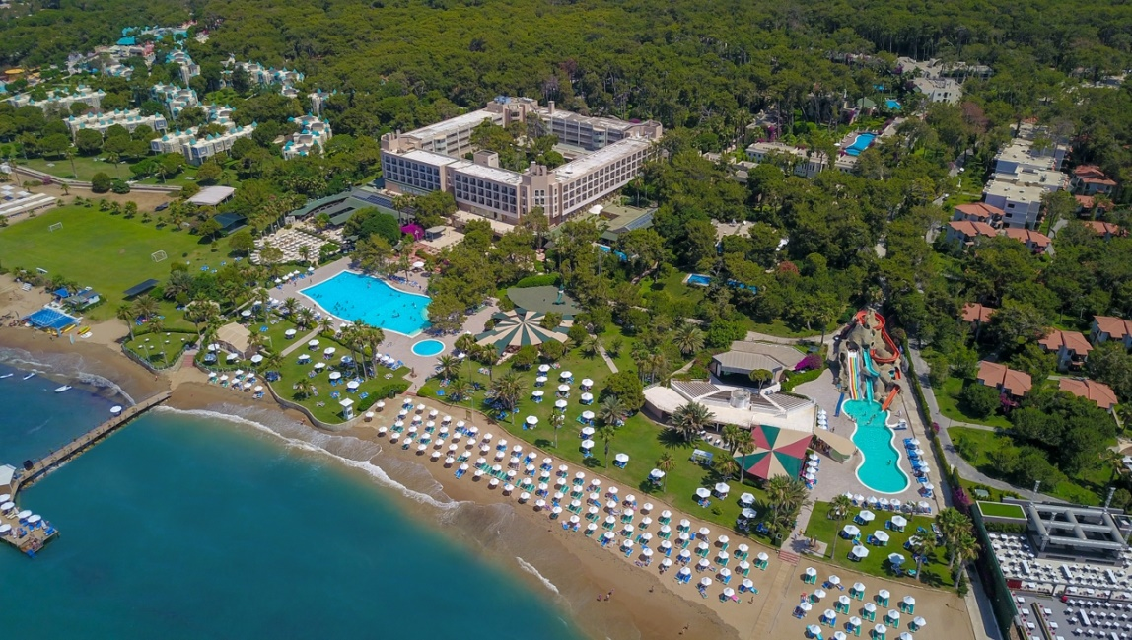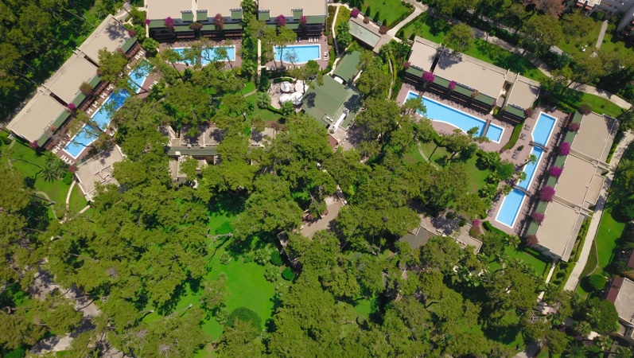

|  |  |
| --- | --- |
| Opening Year | 1988 |
| Concept | Ultra All Inclusive |
| Season | 14.04.2023 – 05.11.2023 |
| Number of Rooms | 486 |
| Number of Beds | 1132 |
| Number of floors | Main building 4 floors / Garden Blocks 2 or 3 floors |
| Internet / Wireless | All area free of charge |
| Available credit cards | Visa Master Card, Euro Card  (Amex Card will not be accepted) |

**GENERAL INFORMATION**

|  |  |
| --- | --- |
| Name | Turquoise Hotel |
| Region | Side - Antalya |
| Telephone | + 90 242 756 93 30 |
| Fax | + 90 242 756 93 45 |
| Web Page | www.turquoise.com.tr |
| E-Mail | info@turquoise.com.tr |
| Adress | Sorgun Mah. Acısu Mevkii No:4 07600 Side/Sorgun - ANTALYA |
| Official Category | 5* |

|  |
| --- |
| **SERVİCES** |

**POOL**

Turquoise Hotel has in total 486 rooms (Deluxe Rooms, Deluxe family rooms, Standard Rooms, Family Rooms and Lake Houses) with sea or garden view. All indoor areas and rooms have air-conditioning systems that can be adjusted to cold or hot temperature according to the season. Lobby, 8 Bars, disco, one outdoor swimming pool, one indoor pool, relax pool (+16), Aquapark with three slides (depending on weather conditions and opening hours), one pool for children and one for babies.   
Mini Club, shopping arcade with hairdresser, market, boutique, photographer, bag and jewelry shops (extra charge). SPA and Wellness Center (extra charge), game land (extra charge), Doctor visit (at stated times, extra charge) and nurse, one meeting room, lifts, laundry service (extra charge), Credit cards are available (except Amex card). Sun loungers, umbrellas and beach towels are provided free of charge on the beach. . Free WIFI in all rooms, in Lobby and Pool area, Sultan Bar. Buggies are free of charge and up on request, wheelchairs for a daily rental available.

|  |
| --- |
| **DISTANCE & TRANSPORTAION** |

|  |  |
| --- | --- |
| Antalya Airport | 65 km |
| Manavgat | 4,5 km |
| Side | 3,5 km |
| Transport | Bus - Taxi |
| Distance to the private beach | 0 m. The hotel is located right on our private beach. |
| Nearest hospital | Akdeniz Hospital – 2 km. |

|  |
| --- |
| **ACCOMODATION** |

Our hotel consists of one main building with 4 floors and with 2 or 3 floors garden blocks and lake houses.

|  |  |  |  |  |
| --- | --- | --- | --- | --- |
| **Room type** | **Location** | **m2** | **Room description** | **Capacity** |
| Standard Room | Garden Block | 27-28 | All rooms are equipped with one French bed, bathroom(shower)/WC, hairdryer, bathrobe/slippers, tiled/laminate floor, balcony, individual air conditioning, direct dial telephone, mini bar (soft drinks, water, beer), kettle with tea /coffee facilities, safe box (free of charge),TV (with music channels). These Rooms are designed to accommodate a maximum of three people (These rooms are suitable for accommodation for 3 people, a sofa or an extra bed will be placed for the 3rd person). And have a garden view. An extra baby bed can be added to the maximum stay. | Max. 2+1  or 3 adults. |
| Deluxe Standard Room | Main Building | 27-28 | All rooms are equipped with one French bed , bathroom(shower)/WC, hairdryer, bathrobe/slippers, laminate/parquet floor, balcony, individual air conditioning, direct dial telephone, mini bar (soft drinks, water, beer), kettle with tea / coffee facilities, safe box (free of charge), TV (with music channels. These Rooms are designed to accommodate maximum three people (These rooms are suitable for accommodation for 3 people, a sofa or an extra bed will be placed for the 3rd person). And are available with garden or sea view.  An extra baby bed can be added to the maximum stay. | Max. 2+1  or 3 adults. |
| Deluxe Family Room | Main Building | 45-52 | All rooms are equipped with 2 bedrooms (first room is a French bed and in the second room are two single beds) (intermediate door), one bathroom (shower)/WC, hairdryer, bathrobe/slippers, laminate/parquet floor, balcony ,individual air-conditioning, direct dial telephone, TV (with music channels), mini bar (soft drinks, water, beer), kettle with tea/coffee facilities, safe box (free of charge) ,TV (with music channels. With sea view.  An extra baby bed can be added to the maximum stay. | Max. 2+2,  3 +1 or  4 adults. |
| Family Room | Garden Block | 42-43 | All rooms are equipped with 2 bedrooms (first room is a French bed and in the second room are two single beds) (intermediate door), one bathroom (shower)/WC, hairdryer, bathrobe/slippers, tiled/laminate floor, balcony ,individual air conditioning, direct dial telephone, mini bar (soft drinks, water, beer), kettle with tea/coffee facilities, safe box (free of charge), TV (with music channels). With garden view. An extra baby bed can be added to the maximum stay. | Max.2+2,  3 +1 or  4 adults. |
| Disabled Room | Main Building or Garden Block | 27-28 | All the rooms are situated on the ground floor with a special design. These rooms are all equipped with one French bed, bathroom/WC, hairdryer, bathrobe/slippers, tiled/laminate floor, balcony, individual air conditioning, direct dial telephone, mini bar (soft drinks, water, beer), kettle with tea/coffee facilities, electronic safe box (free of charge ), TV (with music channels). With garden view. Additionally, the Turquoise Hotel has ramps & elevators for easy access. | Max. 2 adult. |
| **PETS ARE NOT ALLOWED** | | | | |

*Check-in time 14:00, check-out time 12:00

**\*\* In accordance with the law no 4207, the use of tobacco, tobacco products, shisha and e-cigarettes are prohibited in closed areas. Those who do not comply with this rule will be penalized.**

|  |
| --- |
| **OUR ULTRA ALL INCLUSIVE CONCEPT** |

|  |
| --- |
| **RESTAURANTS** |

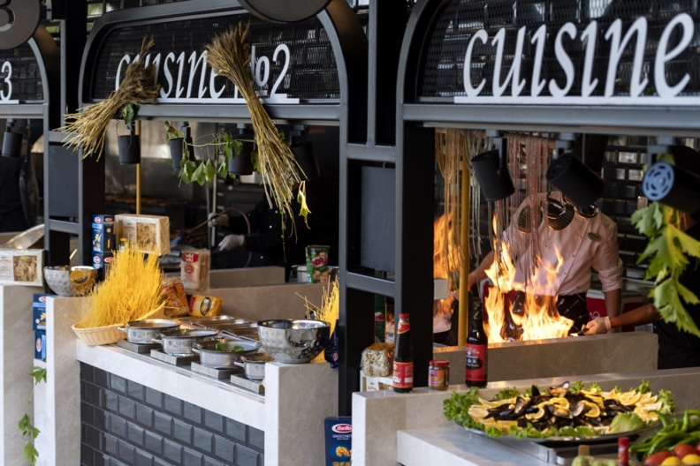 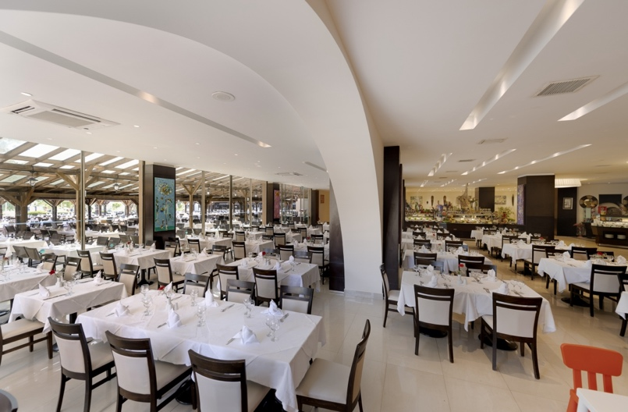

Turquoise Hotel offers delicious examples from all around the world and Turkish Cuisine. Guests of Turquoise Hotel can taste different flavors at the theme nights at Kervansaray Restaurant.

|  |
| --- |
| **֎ KERVANSARAY RESTAURANT** |

|  |  |
| --- | --- |
| Breakfast | 07:00 - 10:00 |
| Late breakfast | 10:00 - 11:00 |
| Lunch | 12:30 - 14:30 |
| Dinner | 19:00 - 21:30 |
| Late night dinner | 21:30 - 24:00 (small buffet) |
| Night breakfast | 24:00 - 07:00 (small buffet) |

Free of charge fresh pressed orange juice served by breakfast time.

|  |  |
| --- | --- |
| **֎ LA CROQUETTA (SNACK REST.)** |  |

12:30–16:00 serves by a la carte.

Available at the snack restaurant: the soup of the day, different sorts of pizza, spaghetti, pide, hamburger, cheeseburger, French fries, baked potato and alternatively chicken or meat döner. Hamburger, cheeseburger, pastry ,sausage and pizza are also available for our younger guests.

Burger Service is available between 16.00 - 17.00.

|  |  |
| --- | --- |
| **֎ BOUGAINVILLEA RESTAURANT :** (only for Lake House guests) |  |

Breakfast 07:30–11:00

Lunch (à la carte style) 12:30–16:00

Dinner (à la carte style) 19:00 – 21:30

|  |  |
| --- | --- |
| **֎ PASTRY TENT** |  |

12:00–16:00

It provides pancake service.

|  |  |
| --- | --- |
| **֎ DİALOGUE PATISSERIE** |  |

11:00–23:00 (Coffee, Tea,Pastries and Sandwiches,)

12:00–17:00 (Ice Cream)

12:00 – 18:00 Waffles are served

**Room service is available 24 hours at extra cost.**

|  |
| --- |
| **A LA CARTE RESTAURANTS** |

Dragon Asian Restaurant : 19.00 - 21.30 for a charge

Italian Restaurant : 19.00 – 21.30 for a charge

Steak House Restaurant : 19.30 – 21.30 for a charge (open between 20 May. – 20 Okt.)

Bougainvillea Restaurant (world kitchen) : 19.00 – 21.30 for a charge

(Bougainvillea Restaurant is free of charge for Lake House Guests)

**A la carte reservation**;

** Reservations for à la carte Restaurants must be made at least the day before for the following day between 11:00–16:00 at the Guest Relation Desk. Based on availability.

** The à la carte Restaurants need minimum 10 guests for opening.

** High Class Beverages and Quality Wines are available from menu card at our à la carte Restaurants with extra charge.

|  |
| --- |
| **BARS** |

|  |  |
| --- | --- |
| **֎ LOBBY LOUNGE BAR** |  |

Lobby Bar is open 24 hours.

It offers several kinds of alcohol & non-alcohol beverages within the concept.

|  |  |
| --- | --- |
| **֎ THE BAR 10** |  |

To the beginning and the end of the season 09:00–18:00.  
In the high season 09:00 – 18:00 /20:00 – 24:00.  
It offers several kinds of alcohol & non-alcohol beverages within the concept.

|  |  |
| --- | --- |
| **֎ BARCORAL BAR** |  |

10.00–17.00   
it offers non- alcohol service.

23.00–01.00   
 serves as disco bar.

|  |  |
| --- | --- |
| **֎ SULTAN BAR** |  |

16:00–24:00

Our main bar is located by the pool and has indoor and outdoor  
sitting area.

It offers several kinds of alcohol & non-alcohol beverages within the concept.

High Class Beverage is by charge also available.

|  |  |
| --- | --- |
| **֎ LA CROQUETTA BAR** |  |

12:30 – 17:00 It offers several kinds of alcohol & non-alcoholic beverages within the concept.

|  |  |
| --- | --- |
| **֎ SUNSET BEACH BAR** |  |

To the beginning and the end of the season 10:00–18:00.  
In the high season 10:00 – 24:00.  
It offers several kinds of alcohol & non-alcohol beverages

within t within the concept.

(Depending on weather conditions, days, hours of services can be changed by Hotel Management).

|  |  |
| --- | --- |
| **֎ KERVANSARAY BAR** |  |

Several kinds of local beverages are offered during lunch and dinner.  
Alcohol beverage service by breakfast time is not possible.

|  |  |
| --- | --- |
| **֎ BOUGAINVILLEA BAR** |  |

09:00–24:00

It offers several kinds of beverages. Waiter service (beverages) to the sun loungers available in the day time; free of charge only for Lake House Guests.

|  |
| --- |
| **֎ MİNİ BAR** |

Mini Bar is filled with soft drinks, soda, water and beer (free of charge). Mini bar will be refilled every day once a day depending on consumption.

**\* As required by law in Turkey, it is forbidden to serve and sell every kind of alcoholic drinks to guests who are under 18 years. Parents are responsible for their children.**

**\* Depending on weather conditions, days, hours and location of services can be changed by Hotel Management.**

**\* Alcoholic drinks are not served at breakfast.**

**\* In all bars bottle service is not available.**

**\* In Main Restaurant only local drinks are served.**

**\* It is forbidden to remove food outside the restaurant due to hygiene conditions. (Those who insist to remove the food are kindly warned.)**

**\* Our guests are assisted if they report food allergen status.**

**\* In Main Restaurant at dinner time there is a Dress Code for all guests. (Those who do not fit the dress code are kindly warned.)**

**\* In accordance with the law no 4207, the use of tobacco, tobacco products, shisha and e-cigarettes is prohibited in closed areas.**

|  |
| --- |
| **SPECIAL OCCASIONS** |

Birthday and special days organizations; Cakes, flowers and special arrangements are offered for a fee by ordering at least one day in advance before giving your special day notice.

In addition, for our honeymoon guests, room decoration, dried fruit, nuts, champagne and breakfast service are offered free of charge in the room once during the stay. For detailed information, please refer to the Guest Relation.

|  |
| --- |
| **BEACH** |

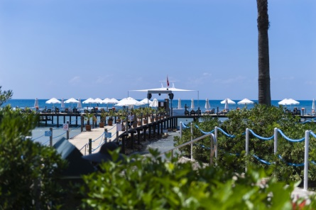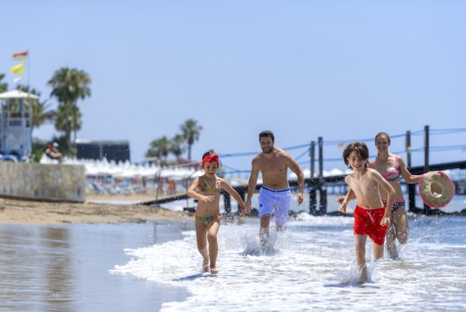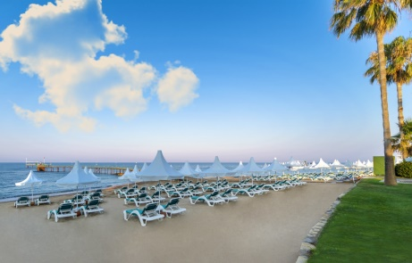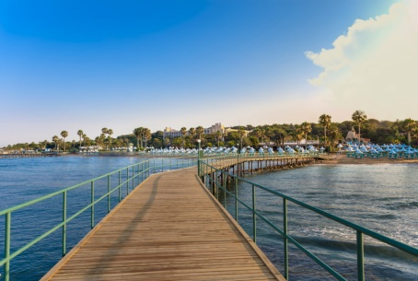

Turquoise Hotel is located just by the beach and has its own 200 m length sand, pebble private beach with two jetties. The long pier is open up the 20. May. (Depending on weather conditions). The long pier has a fishing place without equipment also.

*It is recommended to wear water shoes as part of the sea is rocky.

*Reserving sunbeds is not allowed.

|  |
| --- |
| **POOLS** |

|  |  |  |  |  |
| --- | --- | --- | --- | --- |
| **POOLS & DEPTH’S** | **Open** | **Closed** | **Fresh Water** | **Depth** |
| Activity Pool | • |  | • | 1 m -1.40 m. |
| Children Pool | • |  | • | 0, 5 m. |
| Aquapark Pool  Children under the age of 12 are allowed but at their own risk and under the responsibility of the parents or guardians. | • |  | • | 0,80 m. – 1,10 m. |
| Relax Pool | • |  | • | 1, 40 m. |
| Indoor Pool |  | • | • | 0,90 m. – 1,40 m. |
| Indoor Children Pool |  | • | • | 0,40 m. |
| Baby Pool | • |  | • |  |
|  | | | | |
| Lake Houses | Open | Closed | Fresh Water | Depth |
| B1 Block | • |  | • | 1,20 m |
| B2 Block | • |  | • | 1,20 m |
| H – F Blocks | • |  | • | 1,20 m |
| G1 Block | • |  | • | 1,20 m |
| G2 Block | • |  | • | 1,20 m |

|  |
| --- |
| **ACTIVITIES & SPOR T & OTHER FACILITIES** |

|  |
| --- |
| **SPORT & FUN** |

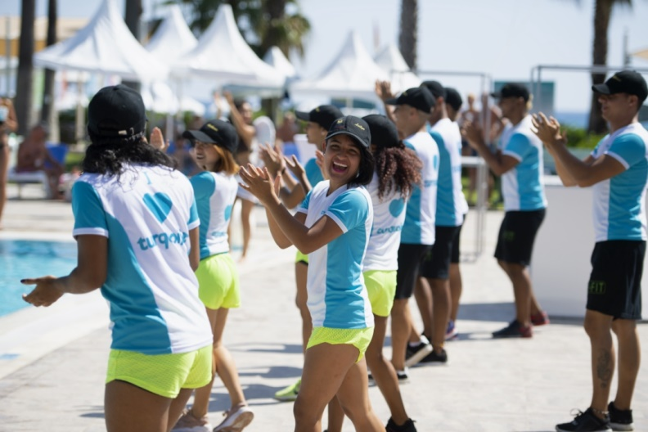

Turquoise Hotel has sport activities every day. Different professional shows (up on 01. May - 15.Oct.) are presented either at the Amphitheatre or at the Sultan Bar. Parties & Live Music are also available.

|  |
| --- |
| **MINI CLUB** |

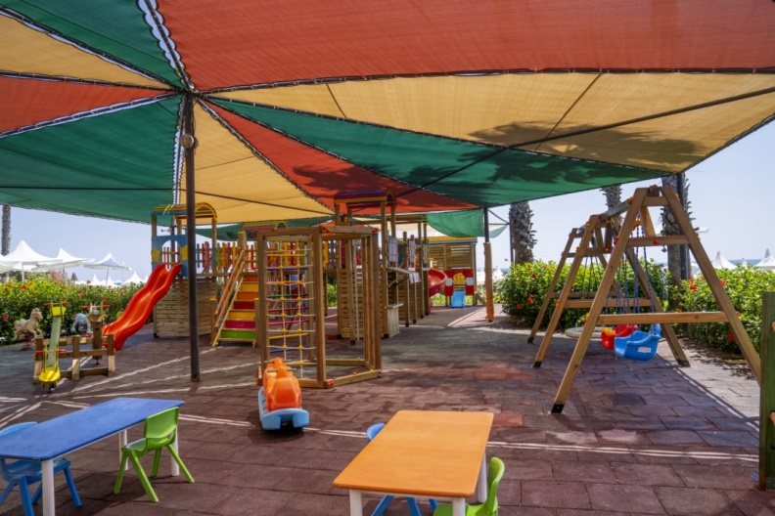

Mini Club (aged between 4–12 years), Teener Club (aged between 13–16 years, only in high season), children’s playground, Mini Disco, Aquapark with three slides (depending on the weather conditions and at stated times) and baby pool. Children’s menu at the Mini Club Snack Bar and little children’s corner at dinner are available.

|  |
| --- |
| **GAME /SPORT & ACTIVITIES (FREE OF CHARGE)** |

• Hamam / Sauna/ Steambath

• Waterslides

• Q2 Signature Fitness Center

• Indoor Pool

• Mini Football

• Table Tennis

• Day,-and Night Animation

• Mini Club Activities

• Basketball

• Beach volleyball

• Boccia, archery, dart

• Badminton

• Aerobic / Yoga

• Watergym

• Umbrella, sun lounger, towels

* Waterball
* Tennis Courts without light (Reservation necessary)

• Buggy (up on request)

• WIFI (general areas and rooms)

• Conference Hall (Overhead projector, TV, video, video projector, DVD player, flipchart, slide projector.)

Meeting facilities (Theatre style) 100 PAX

|  |
| --- |
| **GAME /SPORT & ACTIVITIES (BY CHARGE )** |

• Spa & Wellness Treatments

• Billiard

• Game land

• Tennis Lessons

• Tennis rockets & court lights

• Scuba Diving Center

• Diverse of Motor and non-motor facilities are with charge.

• Hairdresser

• Shopping Center

* Doctor / Nurse Treatments/ Wheelchair

• Telephone, Fax & Connection Service

• Laundry, Iron Service

• Rent a car

|  |
| --- |
| **AWARDS** |

* BOOKING.COM - 2022
* BLUE FLAG - 2022
* HOLIDAYCHECK - 2022
* GREEN KEY - 2022
* CORAL TRAVEL STARWAY - AWARD - 2021
* TUI UMWELT CHAMPION – 2020
* BLUE FLAG - 2020
* HOLIDAY CHECK – 2018
* TRIPADVISOR TRAVELLERS CHOICE – 2018
* TOP HOTEL PARTNER – 2017
* TUI TOP QUALITY – 2017
* TUI TOP QUALITY – 2016
* BLUE FLAG – 2016
* GREEN KEY – 2016
* CORENDON AWARD – 2016
* TOP HOTEL PARTNER – 2017
* TUI HOLLY – 2016
* TUI TOP QUALITY – 2015
* CORENDON AWARD – 2015
* TOP HOTEL PARTNER – 2015
* ZOOVER AWARD – 2013 ~ 2015
* HOLIDAYCHECK – 2015
* BOOKING.COM AWARD (8,5) - 2015
* GREEN KEY – 2015
* BLUE FLAG – 2015
* BOOKING.COM AWARD – 2014
* BOOKING.COM GUEST REVIEW – 2014
* TUI HOLLY – 2014
* TUI UMVELL CHAMPION – 2014
* TRIP ADVISOR WINNER – 2014
* CORALTRAVEL STARWAY – 2014
* HOLIDAYCHECK – 2014
* ZOOVER – 2014
* THOMSON GOLD MEDAL – 2013
* TRAVEL SILVER LIFE - 2013